Decision Tree

The BondTelco Company need to determine the churn rate of their clients, to achieve this a data set have been provided by their IT staffs to help make the decision. The data has 20,000 rows and the 12 columns including the outcome variable (LEAVE). The outcome variable was converted to a factor variable and the remaining variables converted to numeric variables. Since it is very difficult to know the variables that would best explain the model, all the variables were included in the model. A control criterion was set to a minimum of 99 %. Below are the codes and output.

|  |
| --- |
| > cat('Importing the data\n')  Importing the data  >  > data = read.csv(file.choose(), header = T)  > cat('Checking the data set')  Checking the data set> head(data)  COLLEGE INCOME OVERAGE LEFTOVER HOUSE HANDSET_PRICE OVER_15MINS_CALLS_PER_MONTH AVERAGE_CALL_DURATION  1 zero 40385 65 23 453600 216 3 5  2 zero 43915 158 15 151890 197 24 5  3 zero 70863 186 9 705316 546 19 5  4 one 27886 63 63 461456 241 1 2  5 zero 31556 71 76 324804 195 15 1  6 zero 84992 197 8 736073 396 1 4  REPORTED_SATISFACTION REPORTED_USAGE_LEVEL CONSIDERING_CHANGE_OF_PLAN LEAVE  1 very_sat little no STAY  2 very_unsat very_high perhaps LEAVE  3 sat very_high no STAY  4 very_unsat little considering STAY  5 unsat little never_thought LEAVE  6 unsat very_little no STAY  > cat('Checking the structure if the data\n')  Checking the structure if the data  >  > str(data)  'data.frame': 20000 obs. of 12 variables:  $ COLLEGE : Factor w/ 2 levels "one","zero": 2 2 2 1 2 2 2 2 2 1 ...  $ INCOME : int 40385 43915 70863 27886 31556 84992 63466 55347 24146 24811 ...  $ OVERAGE : int 65 158 186 63 71 197 67 59 203 0 ...  $ LEFTOVER : int 23 15 9 63 76 8 0 0 8 59 ...  $ HOUSE : int 453600 151890 705316 461456 324804 736073 728459 922404 276961 693081 ...  $ HANDSET_PRICE : int 216 197 546 241 195 396 254 331 332 225 ...  $ OVER_15MINS_CALLS_PER_MONTH: int 3 24 19 1 15 1 4 13 25 0 ...  $ AVERAGE_CALL_DURATION : int 5 5 5 2 1 4 14 15 6 2 ...  $ REPORTED_SATISFACTION : Factor w/ 5 levels "avg","sat","unsat",..: 4 5 2 5 3 3 4 4 5 5 ...  $ REPORTED_USAGE_LEVEL : Factor w/ 5 levels "avg","high","little",..: 3 4 4 3 3 5 3 5 3 3 ...  $ CONSIDERING_CHANGE_OF_PLAN : Factor w/ 5 levels "actively_looking_into_it",..: 4 5 4 2 3 4 4 2 1 2 ...  $ LEAVE : Factor w/ 2 levels "LEAVE","STAY": 2 1 2 2 1 2 2 2 1 1 ...  > library(dplyr)  >  > head(data)  COLLEGE INCOME OVERAGE LEFTOVER HOUSE HANDSET_PRICE OVER_15MINS_CALLS_PER_MONTH AVERAGE_CALL_DURATION  1 zero 40385 65 23 453600 216 3 5  2 zero 43915 158 15 151890 197 24 5  3 zero 70863 186 9 705316 546 19 5  4 one 27886 63 63 461456 241 1 2  5 zero 31556 71 76 324804 195 15 1  6 zero 84992 197 8 736073 396 1 4  REPORTED_SATISFACTION REPORTED_USAGE_LEVEL CONSIDERING_CHANGE_OF_PLAN LEAVE  1 very_sat little no STAY  2 very_unsat very_high perhaps LEAVE  3 sat very_high no STAY  4 very_unsat little considering STAY  5 unsat little never_thought LEAVE  6 unsat very_little no STAY  > cat('Converting the variables to numeric')  Converting the variables to numeric> data$COLLEGE = as.numeric(data$COLLEGE)  > data$INCOME = as.numeric(data$INCOME)  > data$OVERAGE = as.numeric(data$OVERAGE)  > data$LEFTOVER = as.numeric(data$LEFTOVER)  > data$HOUSE= as.numeric(data$HOUSE)  > data$HANDSET_PRICE = as.numeric(data$HANDSET_PRICE)  > data$OVER_15MINS_CALLS_PER_MONTH = as.numeric(data$OVER_15MINS_CALLS_PER_MONTH)  > data$AVERAGE_CALL_DURATION = as.numeric(data$AVERAGE_CALL_DURATION)  > data$REPORTED_SATISFACTION = as.numeric(data$REPORTED_SATISFACTION)  > data$REPORTED_USAGE_LEVEL = as.numeric(data$REPORTED_USAGE_LEVEL)  > data$CONSIDERING_CHANGE_OF_PLAN = as.numeric(data$CONSIDERING_CHANGE_OF_PLAN)  > data$LEAVE = data$LEAVE  > cat('PArtitioning data into training and testing')  PArtitioning data into training and testing> set.seed(1234)  > ind= sample(2, nrow(data), replace = T, prob = c(0.7,0.3))  > trainData = data[ind==1,]  > testData = data[ind==2,]  > cat('Building a decision tree')  Building a decision tree> library(party)  > myTree = ctree(LEAVE~., data= trainData, controls = ctree_control(mincriterion = 0.99, minsplit =500 ))  > myTree  Conditional inference tree with 15 terminal nodes  Response: LEAVE  Inputs: COLLEGE, INCOME, OVERAGE, LEFTOVER, HOUSE, HANDSET_PRICE, OVER_15MINS_CALLS_PER_MONTH, AVERAGE_CALL_DURATION, REPORTED_SATISFACTION, REPORTED_USAGE_LEVEL, CONSIDERING_CHANGE_OF_PLAN  Number of observations: 14022  1) OVERAGE <= 107; criterion = 1, statistic = 783.133  2) HOUSE <= 599078; criterion = 1, statistic = 219.846  3) OVERAGE <= 24; criterion = 1, statistic = 83.231  4) LEFTOVER <= 24; criterion = 1, statistic = 43.033  5) LEFTOVER <= 0; criterion = 1, statistic = 270.5  6)* weights = 1067  5) LEFTOVER > 0  7) COLLEGE <= 1; criterion = 1, statistic = 36.446  8) HOUSE <= 307739; criterion = 1, statistic = 46.315  9)* weights = 262  8) HOUSE > 307739  10)* weights = 295  7) COLLEGE > 1  11)* weights = 536  4) LEFTOVER > 24  12) LEFTOVER <= 44; criterion = 0.998, statistic = 14.33  13)* weights = 314  12) LEFTOVER > 44  14)* weights = 739  3) OVERAGE > 24  15) LEFTOVER <= 23; criterion = 0.994, statistic = 11.954  16)* weights = 1884  15) LEFTOVER > 23  17)* weights = 1034  2) HOUSE > 599078  18) INCOME <= 99793; criterion = 1, statistic = 212.799  19)* weights = 2126  18) INCOME > 99793  20) LEFTOVER <= 27; criterion = 1, statistic = 27.211  21) OVERAGE <= 15; criterion = 1, statistic = 21.667  22)* weights = 356  21) OVERAGE > 15  23)* weights = 359  20) LEFTOVER > 27  24)* weights = 363  1) OVERAGE > 107  25) HOUSE <= 601673; criterion = 1, statistic = 593.974  26)* weights = 3093  25) HOUSE > 601673  27) INCOME <= 100057; criterion = 1, statistic = 398.734  28)* weights = 1093  27) INCOME > 100057  29)* weights = 501  > cat('Plotting the decision Tree')  Plotting the decision Tree> plot(myTree) |
|  |
| |  | | --- | | > | |

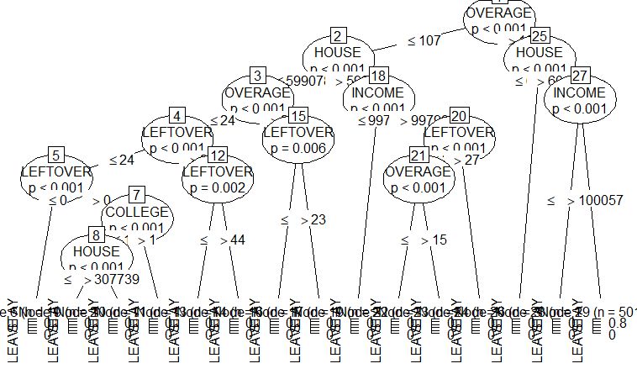

The figure above shows that OVERAGE AND HOUSE were the best variables to be used in the model. To confirm this, restriction were added on the model. Below is the results obtained

> cat('changing the restrictions')

changing the restrictions> myTree = ctree(LEAVE~., data= trainData, controls = ctree_control(mincriterion = 0.99, minsplit =5000 ))

> #myTree

> plot(myTree)

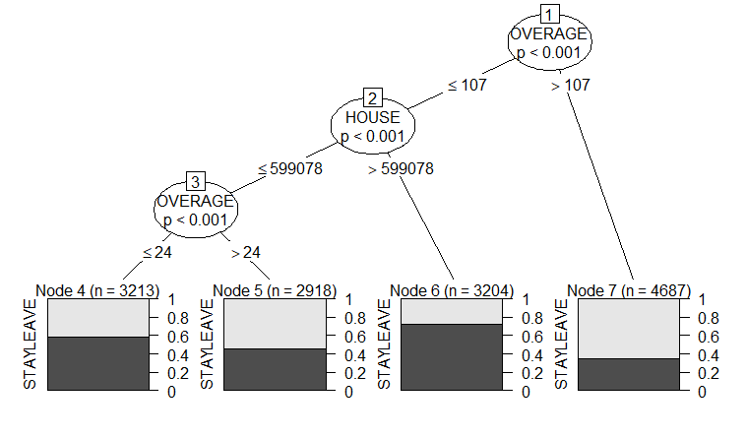

The figure below confirms our statement. OVERAGE and HOUSE were the best variables for the prediction. Therefore, we can subset the data and select the two variables for the model.

> # importing the library to be used to subset the data

> library(dplyr)

>

> # Converting the data into the required data type

> ddt = select(data, LEAVE, HOUSE, OVERAGE)

> ddt$LEAVE = as.factor(ddt$LEAVE)

> ddt$HOUSE= as.numeric(ddt$HOUSE)

> ddt$OVERAGE = as.numeric(ddt$OVERAGE)

> # partitioning into training and testing

> set.seed(1234)

> ind= sample(2, nrow(ddt), replace = T, prob = c(0.7,0.3))

> trainData = ddt[ind==1,]

> testData = ddt[ind==2,]

> # Building a decision tree

> library(party)

> myTree = ctree(LEAVE~., data= trainData, controls = ctree_control(mincriterion = 0.99, minsplit =4500 ))

> myTree

Conditional inference tree with 5 terminal nodes

Response: LEAVE

Inputs: HOUSE, OVERAGE

Number of observations: 14022

1) OVERAGE <= 107; criterion = 1, statistic = 783.133

2) HOUSE <= 599078; criterion = 1, statistic = 219.846

3) OVERAGE <= 24; criterion = 1, statistic = 83.231

4)* weights = 3213

3) OVERAGE > 24

5)* weights = 2918

2) HOUSE > 599078

6)* weights = 3204

1) OVERAGE > 107

7) HOUSE <= 601673; criterion = 1, statistic = 593.974

8)* weights = 3093

7) HOUSE > 601673

9)* weights = 1594

> plot(myTree)

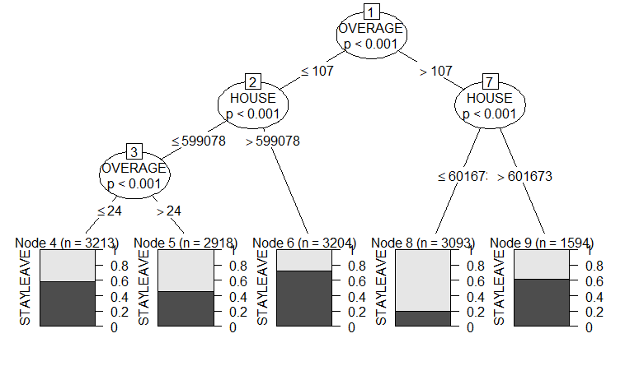

This is the final prediction for the model.